**// Subroutine : UpdateButtonClick_CUSOMTIZE_FASTENING()**

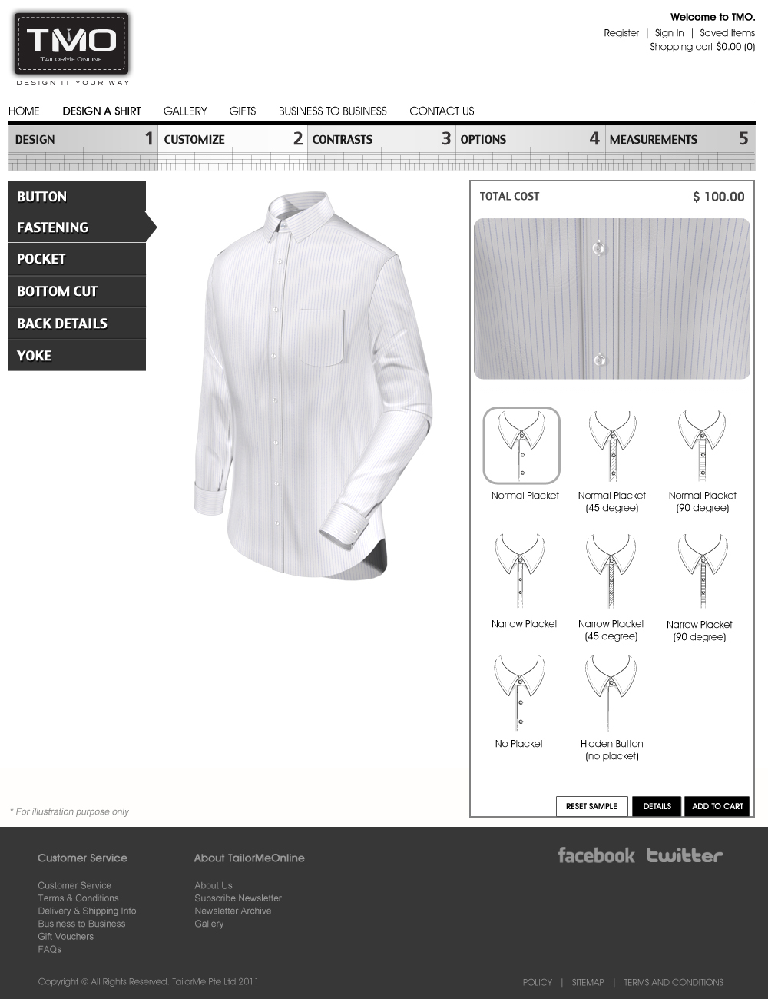

Upon clicking “Normal Placket”:

PlacketLyr02[5] = “Show”;

PlacketLyr02[2] = “NormPlacket”;

PlacketLyr02[3] = “.”;

PlacketLyr03[5] = “Show”;

PlacketLyr04[5] = “Show”;

TieFixLyr02[5] = “Show”;

TieFixLyr02[2] = “NormPlacket”;

TieFixLyr02[3] = “.”;

CollarLyr03[5] = “Show”;

CollarLyr03[2] = “NormPlacket”;

CollarLyr03[3] = “.”;

CollarLyr08[5] = “Show”;

CollarLyr09[5] = “Show”;

ShirtLyr03[5] = “Show”;

ShirtLyr03[2] = “NormPlacket”;

ShirtLyr03[3] = “.”;

ShirtLyr06[5] = “Show”;

ShirtLyr07[5] = “Show”;

Call Subroutine : RefreshFilenames();

Call Subroutine : DisplayPlacket(); // This updates the placket window

Call Subroutine : DisplayFullview(); // This updates the full shirt window

Upon clicking “Normal Placket (45 degree)”:

PlacketLyr02[5] = “Show”;

PlacketLyr02[2] = “NormPlacket”;

PlacketLyr02[3] = “45deg.”;

PlacketLyr03[5] = “Show”;

PlacketLyr04[5] = “Show”;

TieFixLyr02[5] = “Show”;

TieFixLyr02[2] = “NormPlacket”;

TieFixLyr02[3] = “45deg.”;

CollarLyr03[5] = “Show”;

CollarLyr03[2] = “NormPlacket”;

CollarLyr03[3] = “45deg.”;

CollarLyr08[5] = “Show”;

CollarLyr09[5] = “Show”;

ShirtLyr03[5] = “Show”;

ShirtLyr03[2] = “NormPlacket”;

ShirtLyr03[3] = “45deg.”;

ShirtLyr06[5] = “Show”;

ShirtLyr07[5] = “Show”;

Call Subroutine : RefreshFilenames();

Call Subroutine : DisplayPlacket(); // This updates the placket window

Call Subroutine : DisplayFullview(); // This updates the full shirt window

Upon clicking “Normal Placket (90 degree)”:

PlacketLyr02[5] = “Show”;

PlacketLyr02[2] = “NormPlacket”;

PlacketLyr02[3] = “90deg.”;

PlacketLyr03[5] = “Show”;

PlacketLyr04[5] = “Show”;

TieFixLyr02[5] = “Show”;

TieFixLyr02[2] = “NormPlacket”;

TieFixLyr02[3] = “90deg.”;

CollarLyr03[5] = “Show”;

CollarLyr03[2] = “NormPlacket”;

CollarLyr03[3] = “90deg.”;

CollarLyr08[5] = “Show”;

CollarLyr09[5] = “Show”;

ShirtLyr03[5] = “Show”;

ShirtLyr03[2] = “NormPlacket”;

ShirtLyr03[3] = “90deg.”;

ShirtLyr06[5] = “Show”;

ShirtLyr07[5] = “Show”;

Call Subroutine : RefreshFilenames();

Call Subroutine : DisplayPlacket(); // This updates the placket window

Call Subroutine : DisplayFullview(); // This updates the full shirt window

Upon clicking “Narrow Placket”:

PlacketLyr02[5] = “Show”;

PlacketLyr02[2] = “NarrowPlacket”;

PlacketLyr02[3] = “.”;

PlacketLyr03[5] = “Show”;

PlacketLyr04[5] = “Show”;

TieFixLyr02[5] = “Show”;

TieFixLyr02[2] = “NarrowPlacket”;

TieFixLyr02[3] = “.”;

CollarLyr03[5] = “Show”;

CollarLyr03[2] = “NarrowPlacket”;

CollarLyr03[3] = “.”;

CollarLyr08[5] = “Show”;

CollarLyr09[5] = “Show”;

ShirtLyr03[5] = “Show”;

ShirtLyr03[2] = “NarrowPlacket”;

ShirtLyr03[3] = “.”;

ShirtLyr06[5] = “Show”;

ShirtLyr07[5] = “Show”;

Call Subroutine : RefreshFilenames();

Call Subroutine : DisplayPlacket(); // This updates the placket window

Call Subroutine : DisplayFullview(); // This updates the full shirt window

Upon clicking “Narrow Placket (45 degree)”:

PlacketLyr02[5] = “Show”;

PlacketLyr02[2] = “NarrowPlacket”;

PlacketLyr02[3] = “45deg.”;

PlacketLyr03[5] = “Show”;

PlacketLyr04[5] = “Show”;

TieFixLyr02[5] = “Show”;

TieFixLyr02[2] = “NarrowPlacket”;

TieFixLyr02[3] = “45deg.”;

CollarLyr03[5] = “Show”;

CollarLyr03[2] = “NarrowPlacket”;

CollarLyr03[3] = “45deg.”;

CollarLyr08[5] = “Show”;

CollarLyr09[5] = “Show”;

ShirtLyr03[5] = “Show”;

ShirtLyr03[2] = “NarrowPlacket”;

ShirtLyr03[3] = “45deg.”;

ShirtLyr06[5] = “Show”;

ShirtLyr07[5] = “Show”;

Call Subroutine : RefreshFilenames();

Call Subroutine : DisplayPlacket(); // This updates the placket window

Call Subroutine : DisplayFullview(); // This updates the full shirt window

Upon clicking “Narrow Placket (90 degree)”:

PlacketLyr02[5] = “Show”;

PlacketLyr02[2] = “NarrowPlacket”;

PlacketLyr02[3] = “90deg.”;

PlacketLyr03[5] = “Show”;

PlacketLyr04[5] = “Show”;

TieFixLyr02[5] = “Show”;

TieFixLyr02[2] = “NarrowPlacket”;

TieFixLyr02[3] = “90deg.”;

CollarLyr03[5] = “Show”;

CollarLyr03[2] = “NarrowPlacket”;

CollarLyr03[3] = “90deg.”;

CollarLyr08[5] = “Show”;

CollarLyr09[5] = “Show”;

ShirtLyr03[5] = “Show”;

ShirtLyr03[2] = “NarrowPlacket”;

ShirtLyr03[3] = “90deg.”;

ShirtLyr06[5] = “Show”;

ShirtLyr07[5] = “Show”;

Call Subroutine : RefreshFilenames();

Call Subroutine : DisplayPlacket(); // This updates the placket window

Call Subroutine : DisplayFullview(); // This updates the full shirt window

Upon clicking “No Placket”:

PlacketLyr02[5] = “Hide”;

PlacketLyr03[5] = “Show”;

PlacketLyr04[5] = “Show”;

TieFixLyr02[5] = “Hide”;

CollarLyr03[5] = “Hide”;

CollarLyr08[5] = “Show”;

CollarLyr09[5] = “Show”;

ShirtLyr03[5] = “Hide”;

ShirtLyr06[5] = “Show”;

ShirtLyr07[5] = “Show”;

Call Subroutine : RefreshFilenames();

Call Subroutine : DisplayPlacket(); // This updates the placket window

Call Subroutine : DisplayFullview(); // This updates the full shirt window

Upon clicking “Hidden Button (no placket)”:

PlacketLyr02[5] = “Hide”;

PlacketLyr03[5] = “Hide”;

PlacketLyr04[5] = “Hide”;

TieFixLyr02[5] = “Hide”;

CollarLyr03[5] = “Hide”;

CollarLyr08[5] = “Hide”;

CollarLyr09[5] = “Hide”;

ShirtLyr03[5] = “Hide”;

ShirtLyr06[5] = “Hide”;

ShirtLyr07[5] = “Hide”;

Call Subroutine : RefreshFilenames();

Call Subroutine : DisplayPlacket(); // This updates the placket window

Call Subroutine : DisplayFullview(); // This updates the full shirt window

**// End of Subroutine : UpdateButtonClick_CUSOMTIZE_FASTENING()**